Dydd Mercher 14th Chwefrof 2018
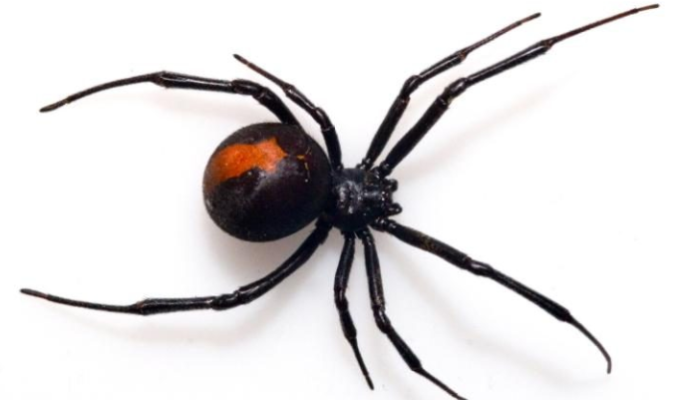
L.O - To write a report on spiders.
Spiders
Spiders are arachnids not insects. They are found in every continent on earth except Antarctica. They also have eight legs as insects only have six. The most common spider in Britain is the house spider and daddy long legs. Are you startled by spiders? Maybe it’s a case of arachnophobia which is an abnormal fear of spiders. Lets discuss this in further detail.
8 legged arachnid

Facts about spiders you probably didn’t know
Did you know that the smallest spider in the world is the Patu Marplesi which could fit ten on the tip of a pencil! Another interesting fact is that spiders have of monkeys, toads, birds and lizards. Also spiders make silk to create webs to catch prey. The giant huntsman spiders have leg- spans thirty cm long, that’s as long as a ruler! The largest specie of tarantula is the Goliath Birdeater. Spiders are vital to a healthy ecosystem, spiders are also cold blooded their blood is blue other than humans. Another cool fact is that once spiders are found in homes the adapting to life indoor.

Wolf spiders
Wolf spiders are members of Lycosidae family of spiders. They can grow a quarter to 2 inches long, in front of the cephalothorax are eyes, mouth, fangs, pedipalps which are used to catch prey. The female wolf spider builds a silk sac containing one hundred eggs, males are attracted to the female by her scent. Since wolf spiders have a flexible abdomen which means they can eat a lot. They are also found living on islands and suburban areas, they also dig burrows and that’s where they spend time.

Spider Habitats
The only place where there’s no spiders is the polar regions, also some spiders get used to living indoor such as house spiders and daddy long legs. Spiders find shelter but cooler temperatures settle in. Some spiders even make a house in yours! Doesn’t matter how much you clean. Humans disturb spiders natural habitats, that’s why the most dangerous spiders are found in random places, some are found on edges of lakes or ponds. Many spiders live much longer in captivity than in the wild, they can survive in the harshest conditions.
Foods
House spiders eat other insects found in the house. The web-building spiders eat flies, mosquitoes, moths and butterflies. Hunting spiders eat insects E.G crickets, grasshoppers and beetles. Some spiders even eat leaves of Acacia tree and a choice of fish, some don’t eat plant food at all. The larger species eat millipedes, wood lice, small parts of lizards, frogs and birds. A normal other thing they eat are plants, some even eat other spiders!

