Curriculum Policy
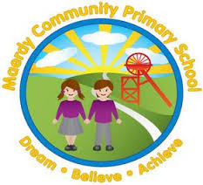
MAERDY COMMUNITY PRIMARY SCHOOL
CURRICULUM POLICY
2025-26

Policy Approved

Headteacher | Chair of Governors
Helen Gregory | Amy Harrison
Date 03/12/25 | Date

Policy Reviewed

Date of review | Reviewer | Details
October 2026
October 2027

Curriculum definition

Our school curriculum is defined as everything our learners experience in pursuit of the four purposes. It is not just what we teach but is also how we teach it and importantly, why we teach it.

Vision

Maerdy Primary School is an inclusive school where children’s individuality is celebrated. The
wellbeing of our children is central to everything that we do. We prepare and motivate our pupils to be successful in a rapidly changing world and strive to remove any barriers to success. We provide a broad, balanced, inclusive and equitable curriculum to all of our learners which has the Four Purposes at its heart. Our children will be given the opportunity to develop skills, knowledge and experiences which are underpinned by high quality teaching and learning which excites and motivates, in the classroom and beyond. The educational journey of a Maerdy Primary School child will be underpinned by excellent teaching. Our children become confident, independent learners who are resilient, eager to embrace challenge and make a positive contribution to society. They recognise their strengths and aspire to achieve their ambitions in a rich, dynamic, caring environment.

Curriculum aims

To make our vision a reality for our learners, our curriculum will:

- enable our learners to realise the four purposes and equip them for ongoing learning, work and life;
- build high expectations and enable all learners to achieve their full potential;
- offer a broad and balanced education, which enables our learners to make links between the different areas of learning and experience (Areas) and apply their learning to new situations and to more complex issues;
- support progression along a continuum of learning;
- support our learners’ health and well-being, including their mental health and well-being;
- support our learners’ development of knowledge that is the foundation of being an informed citizen;
- recognise our learners’ identity, language(s), ability and background and the different support they may need given their particular circumstances;
- reflect the diversity of perspectives, values and identities which shape our locality and Wales and develop understanding of the wider world;
- enable our learners to make sense of growing up in contemporary Wales and of issues which will be important in the future, including well-being, sustainable development and citizenship;
- support our learners to critically engage with a range of information and to assess its value and validity;
- enable our learners to develop an understanding of their rights and the rights of others.
- be built in co-construction with our stakeholders (learners, families, the wider community, our cluster colleagues)

Curriculum structure and design

The four purposes

The four purposes are the aspiration for all learners in Wales.
Our curriculum is designed so that all our learners will be supported to develop as:

ambitious, capable learners who:
- set themselves high standards and seek and enjoy challenge
- are building up a body of knowledge and have the skills to connect and apply that knowledge in different contexts
- are questioning and enjoy solving problems
- can communicate effectively in different forms and settings, using both Welsh and English
- can explain the ideas and concepts they are learning about
- can use number effectively in different contexts
- understand how to interpret data and apply mathematical concepts
- use digital technologies creatively to communicate, find and analyse information
- undertake research and evaluate critically what they find
and are ready to learn throughout their lives

enterprising, creative contributors who:
- connect and apply their knowledge and skills to create ideas and products
- think creatively to reframe and solve problems
- identify and grasp opportunities
- take measured risks
- lead and play different roles in teams effectively and responsibly
- express ideas and emotions through different media
- give of their energy and skills so that other people will benefit
and are ready to play a full part in life and work

ethical, informed citizens who:
- find, evaluate and use evidence in forming views
- engage with contemporary issues based upon their knowledge and values
- understand and exercise their human and democratic responsibilities and rights
- understand and consider the impact of their actions when making choices and acting
- are knowledgeable about their culture, community, society and the world, now and in the past
- respect the needs and rights of others, as a member of a diverse society
- show their commitment to the sustainability of the planet
and are ready to be citizens of Wales and the world

healthy, confident individuals who:
- have secure values and are establishing their spiritual and ethical beliefs
- are building their mental and emotional well-being by developing confidence, resilience and empathy
- apply knowledge about the impact of diet and exercise on physical and mental health in their daily lives
- know how to find the information and support to keep safe and well
- take part in physical activity
- take measured decisions about lifestyle and manage risk
- have the confidence to participate in performance
- form positive relationships based upon trust and mutual respect
- face and overcome challenge
- have the skills and knowledge to manage everyday life as independently as they can
and are ready to lead fulfilling lives as valued members of society.

The four purposes are the starting point for all decisions around curriculum design our curriculum is planned in a way that supports our learners to make progress toward them.

Integral skills

The four purposes are also underpinned by integral skills which will be developed through a wide range of teaching and learning within our curriculum.

Creativity and innovation
Our curriculum will be designed in a way that develops our learners’ creativity and innovation by providing the space for and the opportunities that support them to:
- be curious and inquisitive, and to generate ideas;
- link and connect disparate experiences, knowledge and skills, and see, explore and justify alternative solutions;
- be able to identify opportunities and communicate their strategies.
This will support our learners to create different types of value.

Critical thinking and problem-solving
Our curriculum will be designed in a way that develops our learners’ critical thinking and problem solving by providing the space for and opportunities that support them to:
- ask meaningful questions, and to evaluate information, evidence and situations;
- analyse and justify possible solutions, recognising potential issues and problems;
- become objective in their decision-making, identifying and developing arguments;
- be able to propose solutions which generate different types of value.

Personal effectiveness
Our curriculum will be designed in a way that develops our learners’ personal effectiveness by providing the space for and opportunities that support them to:
- develop emotional intelligence and awareness helping them to become confident and independent;
- lead debate and discussions, helping them to become aware of the social, cultural, ethical and legal implications of their arguments;
- evaluate their learning and mistakes, helping them to identify areas for development;
- become responsible and reliable;
- be able to identify and recognise different types of value and then use that value.

Planning and organising
Our curriculum will be designed in a way that develops our learners’ planning and organising by providing the space for and opportunities that support them to:
- set goals, make decisions and monitor interim results (where developmentally appropriate);
- reflect and adapt, as well as manage time, people and resources.
- check for accuracy and be able create different types of value.
- develop an appreciation of sustainable development and the challenges facing humanity
- develop awareness of emerging technological advances
- confidently meet the demands of working in uncertain situations, as changing local, national and global contexts result in new challenges and opportunities for success
- generate creative ideas and to critically evaluate alternatives
- build their resilience and develop strategies which will help them manage their well-being – they should be encountering experiences where they can respond positively in the face of challenge, uncertainty or failure
- learn to work effectively with others, valuing the different contributions they and others make – they should also begin to recognise the limitations of their own work and those of others as they build an understanding of how different people play different roles within a team.

Areas of Learning and Experience (Areas)

Our school curriculum is designed in a way that ensures learning and teaching that encompasses all six Areas of Learning and Experiences (Areas)

- Expressive arts
- Health and well-being
- Humanities
- Languages, literacy and communication
- Mathematics and numeracy
- Science and technology

All Areas have equal status within our curriculum.

Statements of what matter

Our school curriculum provides opportunities for our learners to engage with and develop their understanding of the key concepts within all the statements of what matter.

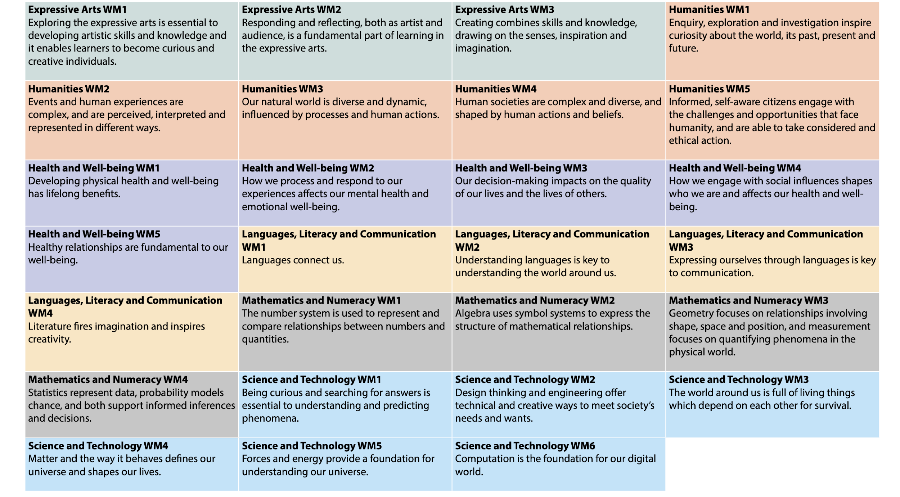

Our curriculum uses the statements of what matter to guide the selection of all curriculum content. Specifically, they are used to:
- select the range of experiences, knowledge and skills that enable our learners to make sense of the ‘big ideas’ and key principles within each statement
- support our learners’ progression within the ‘big ideas’ and key principles and their ability to be able to develop an increasingly sophisticated understanding and application of the statements of what matter
- allow learners to explore topics and ideas through different lenses – the same concept or idea will be explored through different statements of what matter
- help our learners to make sense of a range of experiences, knowledge and skills within each Area by ensuring that content helps learners to develop a coherent understanding of a range of information.

Descriptions of learning

At our school, we use the descriptions of learning as a planning tool to inform the wide range of knowledge, skills and experiences within our curriculum. Our curriculum also uses the descriptions of learning to inform planning for a range of contexts for learning across a progression step to create depth and breadth across our curriculum.

Our curriculum does not use the descriptions of learning to create stand-alone tasks, activities, assessment tasks or interim reports to make judgements about our learners’ outcomes at a particular point on the continuum.

Progression

Progression in learning is a process of increasing depth, sophistication, engagement and learner control, rather than of covering a body of content. Progression is not linear and different learners are likely to progress in markedly different ways. Progression is at the heart of our curriculum design. When selecting the content of our curriculum and assessment, we use the principles of progression for each Area to inform our approach to progression.

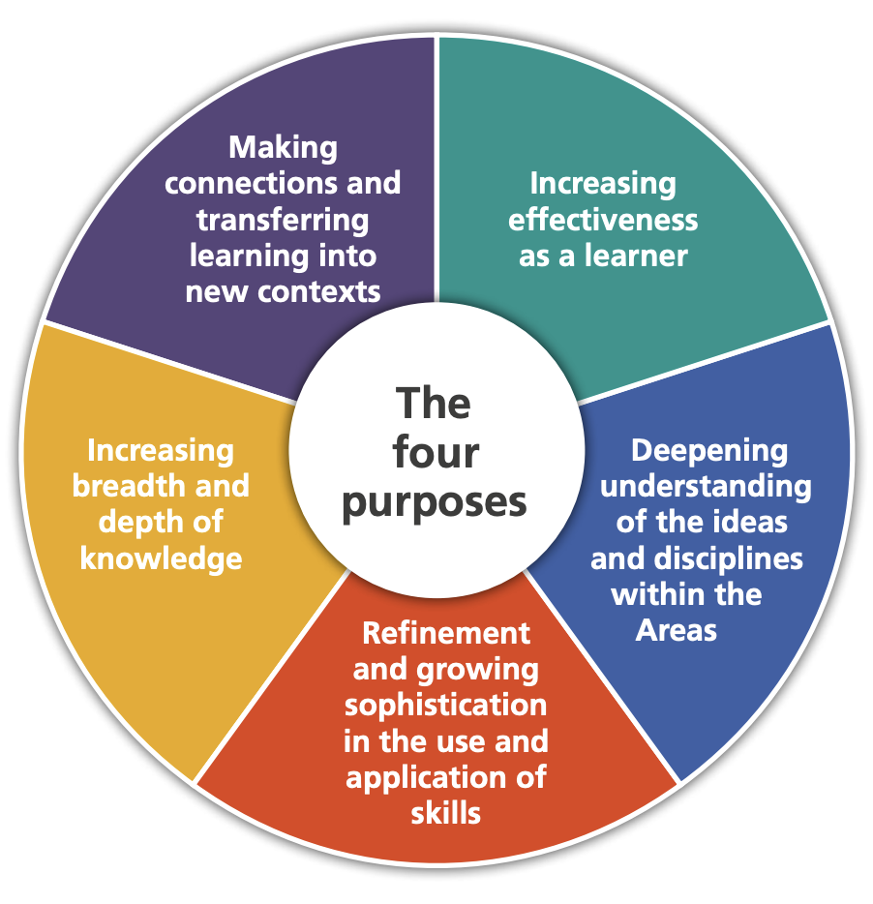

To support our practitioners in developing a shared understanding and joint expectation of how our learners should progress, we will facilitate opportunities and professional dialogue that allow them to:
- develop a shared understanding of progression within each Area (considering the meaning and application of the principles of progression, statements of what matter and information from the ‘designing your curriculum’ section in each Area);
- develop a shared understanding of the importance of progression in effective curriculum and assessment design, and how to establish the purpose of any learning;
- consider the most appropriate ways to assess progress to support all our learners;
- consider how learner progress in the cross-curricular skills and integral skills within each Area should be embedded and how they can be refined so that our learners can apply these across our curriculum;
- explore how meaningful connections can be made between the different Areas and disciplines across our curriculum;
- work with colleagues across the cluster to further develop their understanding and support coherent progression, including transition (please see the cluster transition plan);
- develop links with networks of schools outside of our cluster to allow our practitioners to work with peers on coherence and ensuring pace and challenge withon our curriculum.

The role of disciplines in our curriculum

In line with the principle of progression ‘Deepening understanding of the ideas and disciplines within the Areas’, as our learners progress through our curriculum, they will have greater opportunities to engage with the different disciplines within each Area and to specialise in them as they reach the later progression steps. To support this, as learners progress through our curriculum, learners will receive discipline-specialist teaching.

Equally, our approach to discipline-specialist curriculum design will still be underpinned by the principle of progression ‘Making connections and transferring learning into new contexts’ meaning that discipline-specific learning and teaching in our curriculum will ensure that appropriate and meaningful links to learning are made across our whole curriculum where appropriate.

Mandatory curriculum elements

Relationships and sexuality education

Relationships and sexuality education (RSE) within our curriculum is planned using the RSE Code and is designed in a way that is developmentally appropriate, inclusive and pluralistic.

An overview of our RSE policy can be found here.
An overview of our RSE scheme of learning/provision map can be found here.

Religion, values and ethics

Religion, values and ethics within our curriculum is planned using the statutory guidance within the Humanities Area and the Agreed Syllabus for our Local Authority.

Cross-curricular skills

We believe that the mandatory cross-curricular skills of literacy, numeracy and digital competence are essential for learners to be able to access knowledge. They enable learners to access the breadth of our curriculum and equips them with the lifelong skills to realise the four purposes. These are skills that can be transferred to the world of work, enabling our learners to adapt and thrive in the modern world.

Our curriculum is designed in a way that enables our learners to develop competence and capability in the cross-curricular skills and extend and apply them across all Areas.
Developing the cross-curricular skills is the responsibility of all practitioners across all Areas at our school.

Across our curriculum, our learners will be given a range of opportunities to:
- develop listening, reading, speaking and writing skills
- be able to use numbers and solve problems in real-life situations
- be confident users of a range of technologies to help them function and communicate effectively and make sense of the world

We will use the Literacy, Numeracy and Digital Competency Frameworks to guide our approach to the development of the cross-curricular skills.

Cross-cutting themes

Relationships and sexuality education (RSE)

We believe that all Areas can contribute to learning in RSE. Our curriculum is designed in a way that identifies and makes authentic and meaningful links between learning within a particular Area and learning within the RSE Code.

Human Rights

We believe that learning about human rights empowers our learners as rights-holders. This enables our learners to critically examine their own attitudes and behaviours and to develop skills to be ethically-informed citizens of Wales and the world, who can be advocates for their rights and the rights of others.

Our curriculum incorporates opportunities for our learners to:
- learn about human rights by developing their understanding of what human rights are and where those rights have come from including. This includes developing their understanding of the UNCRC and UNCRPD.
- learn through human rights which supports our learners to develop values, attitudes and behaviours that reflect human rights.
- learn for human rights, which motivates them to social action, empowerment of active citizenship and to advance respect for the rights for all.

Diversity

We want our curriculum to recognise and celebrate the diversity that exists within the social groups within our school community, the communities we serve and society as a whole. We want our learners to be aware of the characteristics of others and treat others with compassion, empathy, understanding and equity, regardless of those characteristics. As our learners progress in our curriculum, they will become increasingly aware of a range of specific characteristics which can define our identity, including sex, gender, race, religion, age, disability and sexuality.

Our curriculum incorporates opportunities for our learners to:
- develop empathy and compassion for others
- celebrate diverse backgrounds, values and characteristics
- develop their own values and sense of identity
- develop understanding of people with different beliefs and perspectives
- challenge stereotypes

Careers and work-related experiences (CWRE)

We believe that learning about CWRE is fundamental to developing skills for work and life.

Our curriculum incorporates opportunities for CWRE that inspires our learners to:
- develop an understanding of the purpose of work in life, both for themselves and for society as a whole
- become increasingly aware of the range of opportunities available to them, broadening their horizons
- develop the attitudes and behaviours required to overcome barriers to employability, career management and lifelong learning
- appreciate the increasing range of opportunities in the workplace where an ability to communicate in Welsh is important
- explore opportunities through a variety of meaningful experiences in learning, work and entrepreneurship
- develop resilience and the ability to be adaptable in response to the challenges, choices and responsibilities of work and life

Our curriculum plans CWRE using the key considerations and influences on career decisions of young people to support the four purposes.

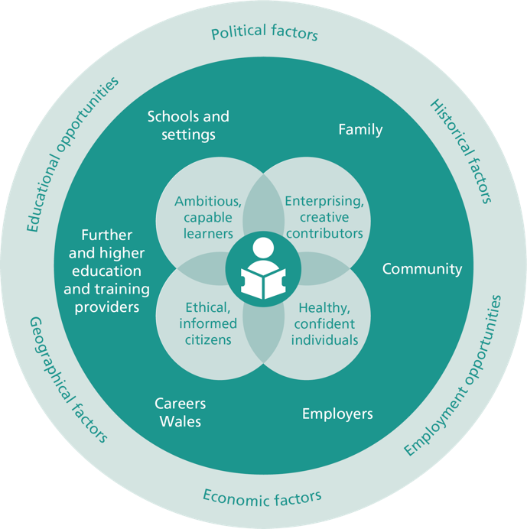

Local, national and international contexts

Local, national and international contexts provide key perspectives for our learners and are important in supporting our learners to realise the four purposes.

Our curriculum incorporates opportunities for our learners to:
- develop learning through a range of places and events of significance
- make links with the local community and organisations
- learn about the contributions and experiences of different individuals that shape each context
- learn about cultural diversity, values, histories and traditions that shape each context
- understand different identities, histories, cultures, perspectives and values that shape communities and societies
- recognise and engage with factors, influences and impacts (including economic, social and environmental impacts) locally, nationally and internationally
- develop an authentic sense of cynefin, building knowledge of different cultures and histories, allowing them to develop a strong sense of individual identity and understanding how this is connected to and shaped by wider influences
- draw on the stories and distinctiveness of our school’s local surroundings
- understand their role as citizens and the structures of government which affect them in each context
- explore, critically analyse and respond to contemporary issues and challenges affecting their lives and the lives of others through each context
- understand sustainable development, the challenges the environment and society face and how they can engage with and make a difference on these issues supporting sustainable citizenship
- understand contemporary Wales, providing opportunities to reflect, understand and analyse contemporary society and their engagement with it
- recognise Wales’ diverse linguistic heritage and culture, and its connections with the rest of the world
- recognise how our languages unlock knowledge about our literature, geography, history and their links beyond Wales
- recognise the links between local, national and international contexts, understanding how they constantly influence each other
- use critical analysis in each context, recognising both positive and challenging aspects within each

A curriculum accessible to all

Through the design of our curriculum, we ensure that our curriculum:

- is suitable for each learner’s age, ability and aptitude
- takes account of each learner’s additional learning needs (ALN), if any
- secures broad and balanced learning and teaching for each learner
- make arrangements for assessing the ability and aptitude of leaners in respect of the relevant curriculum, on entry to a school or setting, to identify the next steps in their progression and the learning and teaching needed to support that progress.

Cynefin

Our curriculum will instil our learners with pride and passion in themselves, our school community, the wider community and Wales. Our curriculum will allow our learners to explore and understand the different identities, landscapes and histories that all come together locally and nationally to form their cynefin. This will allow our learners to develop their own sense of identity and to understand the identities of others and make connections with people, histories and landscapes elsewhere in Wales and internationally.

Learning and teaching

Our vision for learning teaching is:
(pedagogy/learning and teaching is at the heart of our curriculum - approaches that support our learners to realise the four purposes – ‘why’ – ‘how’ – ‘what’ – vision recognises the integral role of the learning environment in supporting effective learning (links to behaviour management?) – strategies specific to our context

At our school, we understand that high-quality teaching is not a formula but instead is:
- built on a clear understanding of pedagogy from leaders and practitioners;
- consistently applied across the school;
- continually revisited for effectiveness;
- grounded in an understanding of why particular strategies have been trialled or are being used;
- based on decisions that are directly linked to learner needs;
- research-informed and evidence-engaged;
- linked to our school vision.

Approaches to learning and teaching
- 12 pedagogical principes
- CSC models for teaching
- Great teaching toolkit
- Education Endowment Foundation

To support our curriculum, pedagogy will help our learners to develop:
- a strong disposition to learning
- strong metacognitive skills
- critical, creative, problem-solving skills
- highly effective communication skills

Our learning environment is a key enabler for our curriculum. It will:
- encourage learners to be independent, to have a say in their own learning and to take increasing responsibility for it
- include all learners
- allow learners of all ages to experience authentic learning opportunities both indoors and outdoors
- enable learners to apply, use, consolidate and extend skills
- be secure and safe

To support this, our practitioners will:
- form positive and respectful relationships with learners and support good relationships between peers
- respond to all learners
- plan engaging and developmentally appropriate learning opportunities informed by regular observation and ongoing assessment of learning and the learner’s stage of development
- prompt learners to think about and reflect upon their learning in order to extend thinking and make connections
- challenge learners and have high expectations
- actively engage with parents, carers and the wider community as partners in learning
- be reflective and seek to engage in ongoing professional learning

Assessment

The purpose and role of assessment within our curriculum
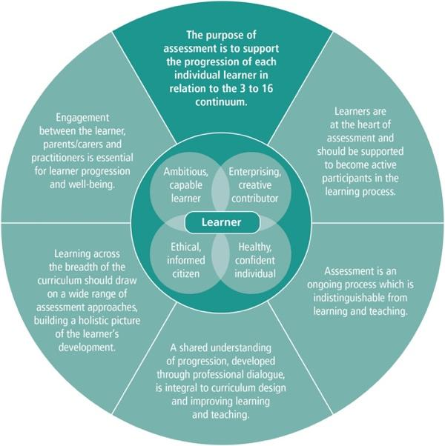
Assessment is an integral part of teaching and learning and plays a fundamental role in enabling our learners to make progress. For assessment to be effective, we recognise that partnerships between our practitioners, our learners and parents and carers are important.

Progression in learning is a process of increasing depth, sophistication, engagement and learner control, rather than of covering a body of content. Progression is not linear and different learners are likely to progress in markedly different ways. Assessment planning and practice, built into the curriculum and classroom practice, should recognise this and allow for a variety of diversions, stops and variations in pace in a learner’s journey.
Learners’ progression should be assessed in relation to the breadth of the school or setting’s curriculum, which is designed to reflect the principles of progression, and informed by the descriptions of learning. As such, practitioners should assess all learners across the 3 to 16 continuum based on the progression articulated in their school or setting’s curriculum and in their planned learning intentions. In doing so, they should take into account the diverse needs of individual learners across the breadth of the curriculum.

The role of different participants in our assessment process

Leaders
Leaders at our school will establish a strong learning culture that supports and challenges our practitioners to enable our learners to make appropriate progress. This is achieved by:
- creating a clear vision for our curriculum that supports our learners’ realisation of the four purposes and supports individual learner progression;
- creating an environment that develops the necessary knowledge and skills to promote learner wellbeing;
- creating an environment based on mutual trust and respect, rather than one focused on compliance and reporting;
- enabling our practitioners to develop the knowledge and skills necessary to carry out their role in assessment effectively;
- ensuring the design, adoption, review and revision of our curriculum that affords opportunities for our practitioners to plan purposeful learning that addresses the needs of each of our learners;
- developing and embedding processes and structures that enable our practitioners to develop a shared understanding of progression;
- ensuring there is a clear picture of learner progression within our school that is understood by all our practitioners, a process that embeds regular ongoing professional dialogue on progression into our systems to support self-reflection and inform improvement;
- ensuring there is a clear understanding of learner progression across our cluster of schools that feeds into discussions on learner progression within each school or setting
- considering how additional challenge and support for our learners can be best provided, including working with other partners
- encouraging engagement between all participants in the learning and teaching process in order to develop effective partnerships
- ensuring that the statutory requirements have been met and that due regard has been paid to this guidance for assessment, and that practitioners are taking account of this in planning, learning and teaching and within daily practice.

Practitioners
Practitioners are our school will plan for and provide effective learning experiences that are appropriate to the age and development of each of our learners. Our practitioners enable learners to appreciate where they are in their learning, where they need to go next and how they will get there. Practitioners support and challenge learners effectively to ensure they each make progress. This is achieved by:
- being clear about the intended learning, and planning engaging learning experiences accordingly;
- supporting the promotion of learner well-being through assessment practice;
- sharing intended learning appropriately with learners;
- evaluating learning, including through observation, questioning and discussion;
- using the information gained from ongoing assessment to reflect on their own practice to inform next steps in teaching and planning for learning;
- providing relevant and focused feedback that actively engages learners, encourages them to take responsibility for their learning, and moves their learning forward;
- encouraging learners to reflect on their progress and, where appropriate, to consider how they have developed, what learning processes they have undertaken and what they have achieved;
- providing opportunities for learners to engage in assessing their own work and that of their peers, and supporting them to develop the relevant skills to do this effectively;
- developing learners’ skills in making effective use of a range of feedback to move their learning forward;
- involving parents and carers in learner development and progression, with the learner’s involvement in this dialogue increasing over time;
- engaging in dialogue with leaders and fellow practitioners to ensure we have a clear picture of the progress being made within our school;
- identifying any additional challenge or support learners may require, engaging with external partners where necessary.

Learners
Our learners will participate in and contribute to the learning process in a way that is appropriate to their age and stage of development. This will help our learners to develop knowledge, skills and understanding, and to apply them in different contexts. As they make progress along our learning continuum with increasing independence, our learners will be supported and encouraged to:
- understand where they are in their learning and where they need to go next;
- develop an understanding of how they will get there;
- respond actively to feedback on their learning, and develop positive attitudes towards receiving, responding to and acting upon feedback in their learning;
- review their progression in learning and articulate this both individually and with others;
- reflect on their learning journey and develop responsibility for their own learning over time.

Parents and carers
Parents, carers have an important role to play in the assessment and we will engage with them so that they can support their child’s progress in an appropriate way.
We will encourage and enable parents and carers to:
- engage regularly with our school and our practitioners in order to understand and support their child’s progression in learning;
- share relevant knowledge and understanding with us which will support their child’s learning and progression;
- respond actively to information provided about their child’s learning and, in collaboration with us, plan ways of supporting that learning within and outside of school.

External partners
We will engage external partners to:
- help our practitioners assess and identify the needs of learners who may require additional support and then help them through the provision of advice and support. This includes specialist educational support and support from other agencies such as health
- provide information about learning progression that has taken place for our learners who may spend some of their time in other contexts.

Supporting each of our learners on an ongoing, day-to-day basis
To support our learners on an individual and ongoing, day-to-day basis, assessment is embedded into everyday classroom practice in a way that supports and is indistinguishable from learning.

Our assessment practices will identify each individual learner’s strengths, achievements, areas for improvement and, where relevant, barriers to learning. This understanding will be used by our practitioners, in discussion with our learners, to ascertain the next steps required to move their learning forward, including any additional challenge and support required.

Understanding group progress in order to reflect on our practice

Assessment enables our practitioners and leaders to understand to what extent and in what ways different groups of our learners are making appropriate progress. Information that flows from assessing our learners’ progress is used to identify strengths and areas for improvement in both the curriculum and daily practice, including consideration of how the needs of our learners as individuals have been met. This ensures our curriculum, and learning and teaching, helps raise the achievement of all our learners. This focus contributes to our understanding of what our learners need in order for them all to maximise their potential, as well as identifying specific challenges and support that particular groups or individual learners might need. This understanding contributes to our processes of self-evaluation and continuous improvement.

Communicating with parents and carers
When communicating and engaging with parents and carers, we share information about:
- the progress their child is making
- their future progression needs
- how future progression needs can be supported at home
- their general well-being in school

Transition

In accordance with the 2022 Transition Regulations our transition plan covers the following matters:
- proposals for managing and co-ordinating the transition of learners from feeder primary schools to the secondary school
- proposals for how continuity of learning will be achieved through curriculum design and planning for learning and teaching for learners in Year 6 transitioning to Year 7
- proposals for how each individual learner’s progression will be supported as they transition from primary school to secondary school
- proposals for how the learning needs and the well-being of each individual learner will be supported as they transition from primary school to secondary school
- proposals for reviewing and monitoring the impact of the transition plan in respect of how it has helped:
  - achieve continuity of learning
  - support individual learner progression

Curriculum Summary
In line with the mandatory requirement for schools to publish a summary of their curriculum, a copy of our curriculum summary can be found here. https://drive.google.com/drive/u/0/search?q=maerdy%20primary%20vision

Curriculum review, evaluation and revision
The review process
It is the responsibility of the Governing Body and headteacher to keep our curriculum and assessment arrangements under review and revise them if they no longer comply with our curriculum policy.

