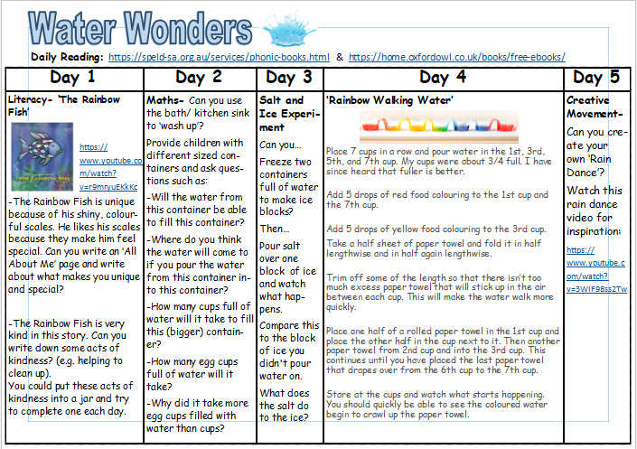
*There are additional mindfulness activities on the website.
*Additional summer Maths activities can also be found on the website. These can be printed or written up in exercise books.

