***Reception Tasks***
Reception Reading-
Continue to use the links below in order to access further reading materials. Please practise daily.
https://home.oxfordowl.co.uk/books/free-ebooks/
https://speld-sa.org.au/services/phonic-books.html
Reception Literacy-
Remember me?
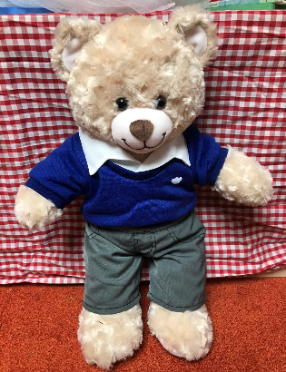

As you know, before school closed- Tuffy came to our class and he was very excited to come home with you all in turn. Tuffy would love to hear what you have been doing for the past few weeks.
Can you write a diary to tell Tuffy what you have been getting up to?
Maths-
Reception- Online “Underwater Counting” and “Higher and Lower” ordering numbers to 10
https://www.topmarks.co.uk/learning-to-count/underwater-counting
https://www.topmarks.co.uk/Flash.aspx?f=HigherAndLower
Topic-
Our new topic in Reception is ‘Under the Sea’.
Can you create an under the sea creature using recyclable materials and household items?
Can you write him a name tag?
Can you find out and write 3 facts about him?
Please upload and tag us in your pictures on Facebook.

Kind regards,
Miss L Derrick

