Nursery, Reception & Year 1 Tasks 08/05/2020

Nursery-
Literacy- Reinforce Letter sounds flashcards.
Identify beginning sounds of words around the home or garden and write the letter to match.
Numeracy- Use a ball or favourite toy to reinforce positional language. Hide the object and ask the question “Where did you find it?”. Encourage your children to use full sentences to answer the question; “the ball was ______ the box”.
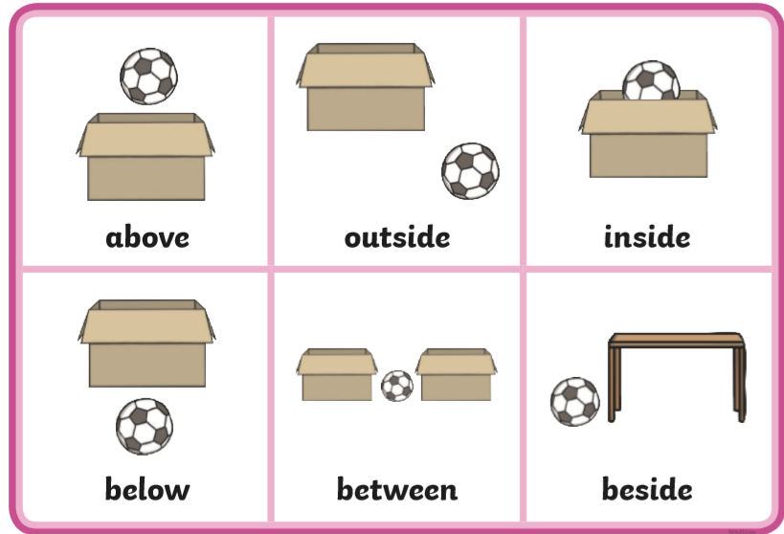
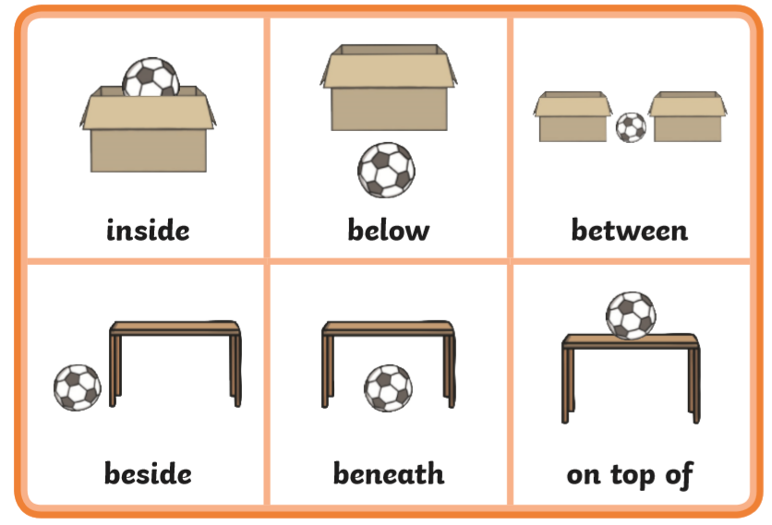
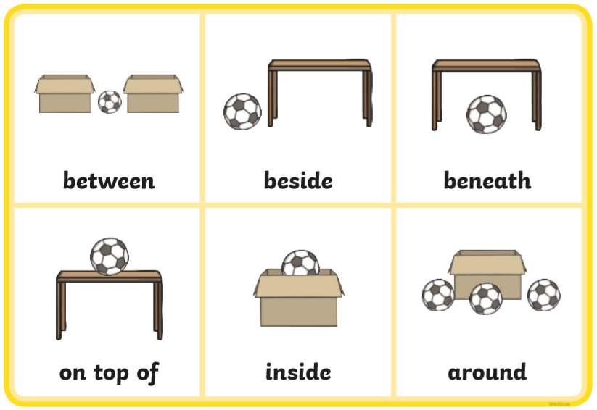

Reception & Year 1 Reading-
Continue to use the links below in order to access further reading materials.
https://home.oxfordowl.co.uk/books/free-ebooks/
https://speld-sa.org.au/services/phonic-books.html

Reception-
Online “Helicopter Rescue Game”. Identify numbers to 10/20/50. Find the numbers more/less than and in between.
https://www.topmarks.co.uk/learning-to-count/helicopter-rescue
Year 1- Doodle Maths in addition to the game above.

Topic
Our new topic in Nursery, Reception and Year 1 is; Muck, Mess and Mixtures.
Make a variety of messy mixtures with your child both indoors and outdoors using everyday household non-toxic liquids. Examples; potions, perfumes, mud pies, natural paints with ground grass, flowers and mud, volcano using vinegar, bicarb and food colouring.
Please upload and tag us in your messy fun pictures on facebook.
Nursery | Reception | Year 1
Use initial sounds to name your ingredients and discuss how to make your potions. | Write a label for your mixture and write a simple list of ingredients that you used with support. | Write a label for your potion.  Write a list of ingredients.  Write the method in a few sentences explaining “how” you made your potion.

