Year 2 Activities 6th July
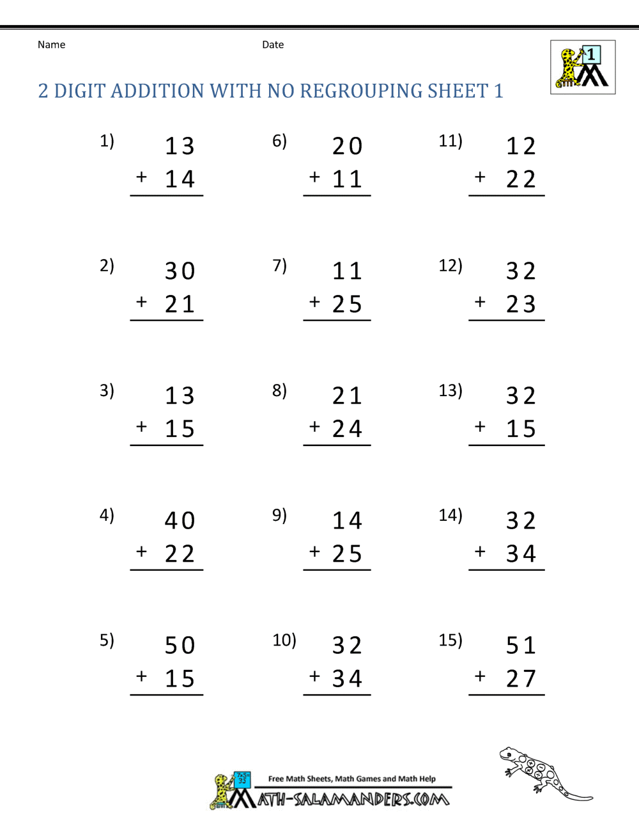
column addition
Remember to always start with the unit column
T U
T U
T U
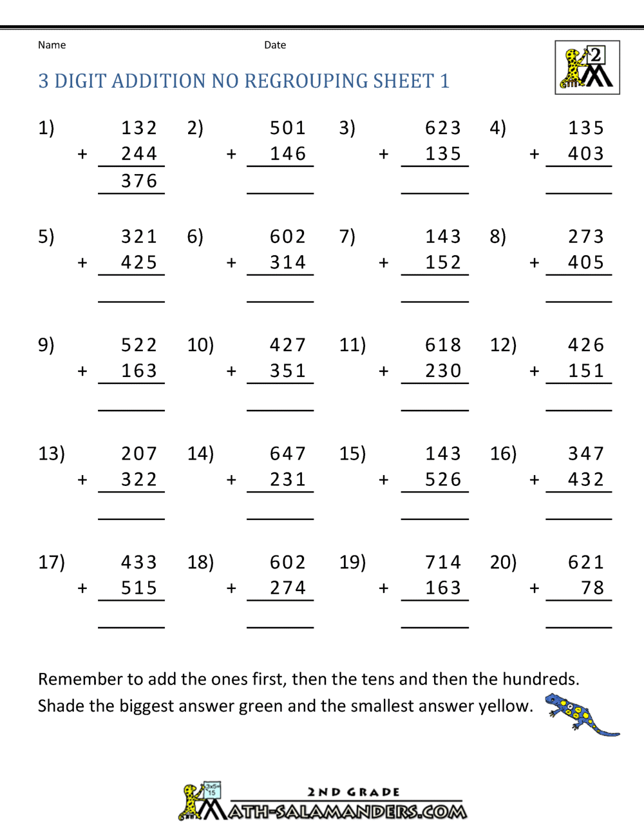
H T U
H T U
H T U
H T U

Remember
Add the units first, then the tens and finally the hundreds column
units

Addition with regrouping (carrying)
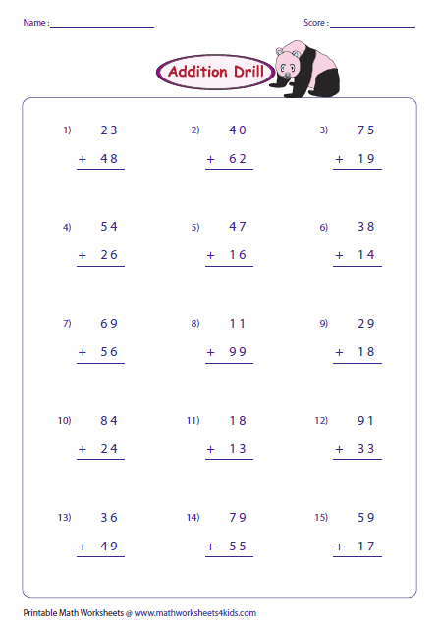

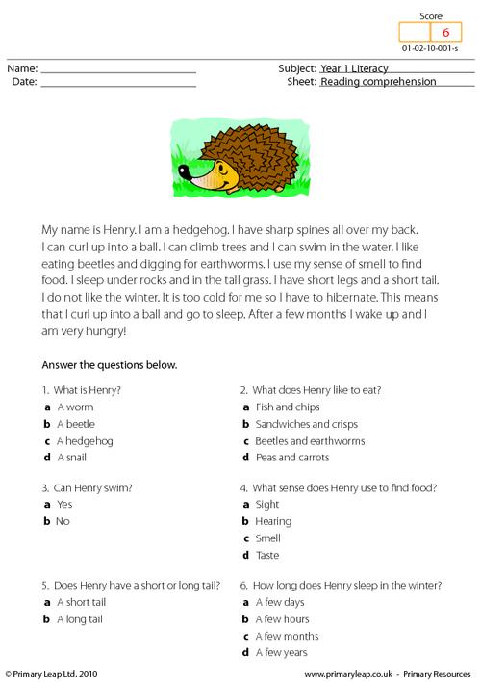
Comprehensionn
Henry the Hedgehog

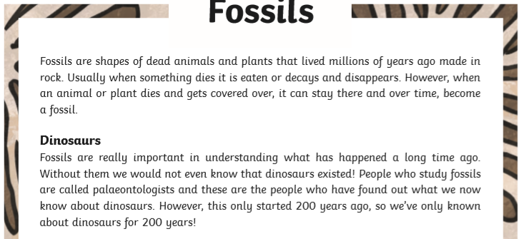

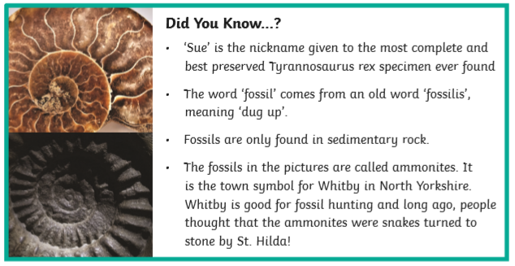

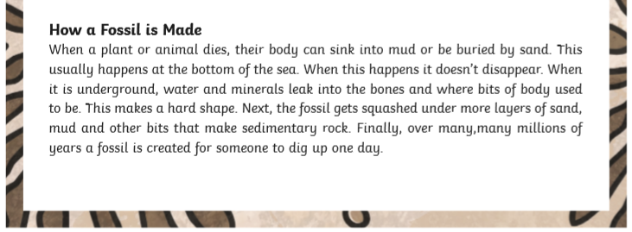

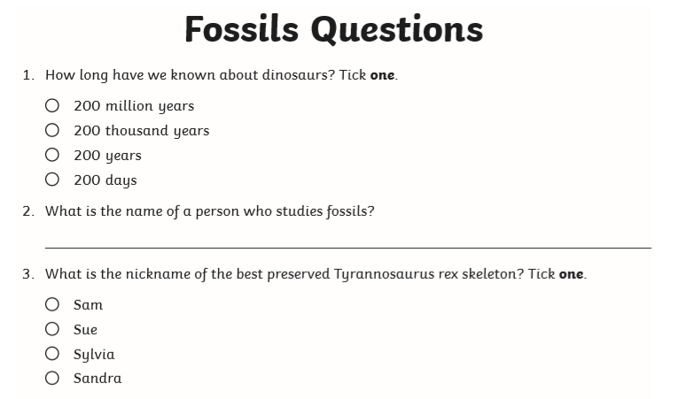

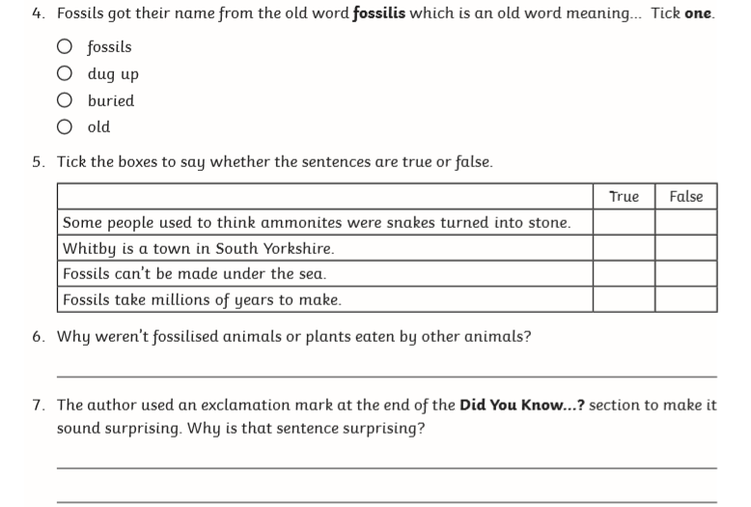

Purple Mash Activities
Activity 1  - Home  - Serial mash  - Diamonds  - Anna and the third leaf  Read chapter 1 of the story complete the task linked to each chapter. Continue the story and activities up to chapter 5. | Activity 2  - Home  - English  - Phonics  - Phase 5  - Phonics phase 5 cloze  Practise using the different phonics to spell words correctly. | Activity 3  - Home  - English  - Grammar  - Early Birds  - Superhero shopping  Drag the words to the correct noun in the sentence to make a new noun that fits into the sentence.
Activity 4  - Home  - Mathematics  - Fractonio’s Pizzeria  Can you follow the instructions to make the correct pizza for the customer. | Activity 5  - Home  - Science  - Seasons  - Summer  - Sun safety  Can you design a sun safety poster? What should you do when it is sunny? What should you wear? How can you protect your skin? | Activity 6  - Home  - Science  - Seasons  - Summer  - Summer clothes  Can you design beach clothes suitable for a boy or girl?
Activity 7  - Home  - Computing  - Logo    Can you programme the roamer to move around the screen? You can change the roamer by clicking and    change the background by clicking  Help move the roamer round the screen by using the logo commands. | Activity 8  - Home  - Art  - Nature  - Island map  Can you design your own treasure island map and include your own key to help the treasure hunters? | Activity 9  - Home  - Topics  - PSHE  - My Friend  Describe the personality and appearance of one of your friends. Why do they make a good friend? What do you like about them? What are you missing about them the most?

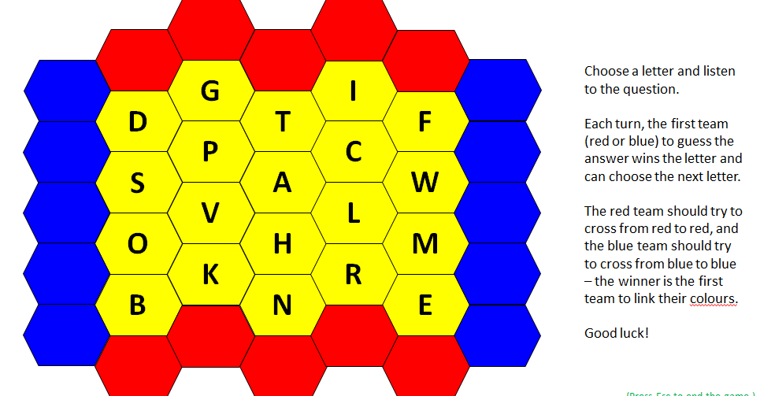
Blockbusters Game

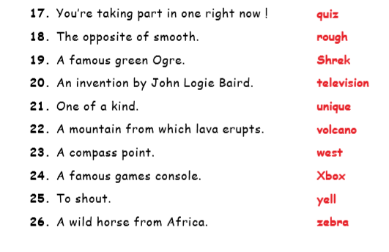
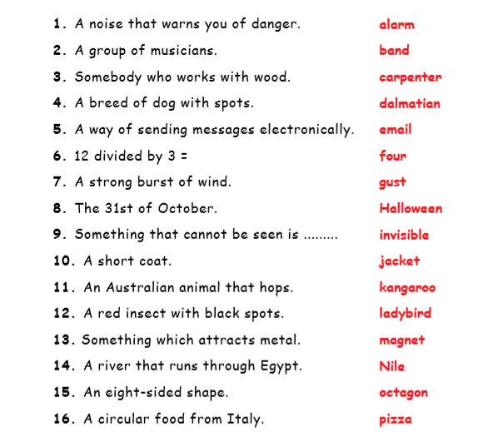
Blockbuster example questions

