Year 2 Activities 26/6/2019
Youtube- Winnie at the seaside – follow the link below and listen to the story.
https://www.youtube.com/watch?v=Z4ockWO_UWY
Activity 1
Purple Mash
*Home
*Topics
*Animals
*Sea Creatures
Can you design your own under the sea pictures?
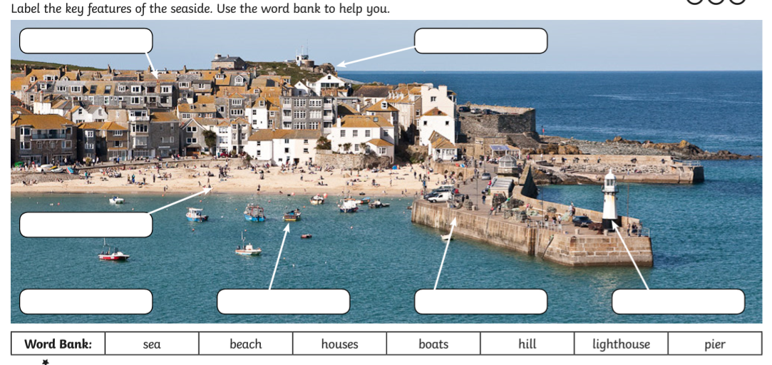
Activity 2

Task 3
Can you put the features of the seaside into the correct column?
Physical features- is something that has been made by nature.
Human features- Is something a person has built in an area.
Physical | Human
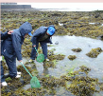
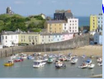
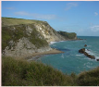
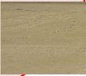
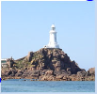
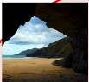


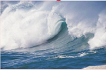
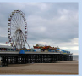

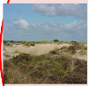
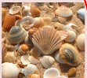
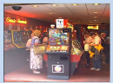
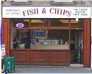
Task 4
Can you make your own lollipops as a treat at the beach?
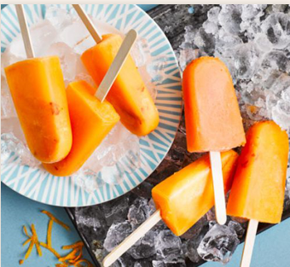
Sunshine Lollipops

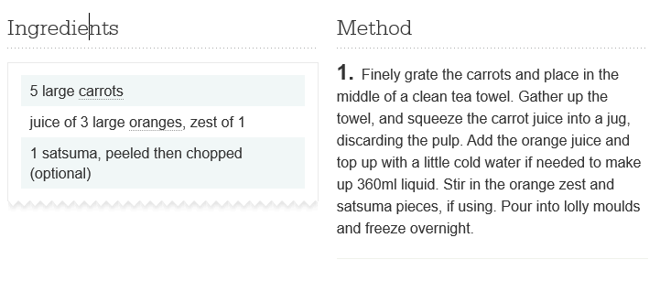

What other lollipop flavours can you make?
Activity 5
- Purple mash
- Home
- Topics
Write a postcard
Imagine you are Winnie and Wilbur. What may your postcard say about your day at the beach? What things did you see?, do, eat, like or dislike?
Activity 6
Seaside Café
How much will each food order cost?
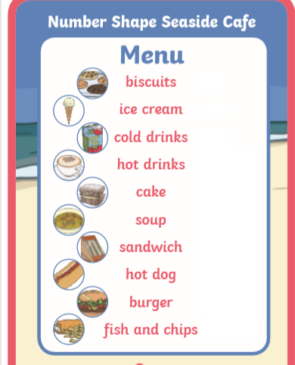

15p
40p
50p

70p
75p
90p
£1.20

65p
80p
£1.50

Order number | Food | cost
1 | Fish and chips  Cold drink
2 | Burger  Cold drink  Ice cream
3 | Ice cream  Cold drink  biscuit
4 | Hot dog  Soup  burger
5 | Cake  Hot drink
6 | Sandwich  Fish and chips  Cold drink

