Year 2 Activities
8.6.20
City Rain fall
Key
1 = =10 cm

City | Rainfall
Cardiff | 
Birmingham | 
Belfast
Swansea

- How much rainfall fell in Birmingham?
- How much rainfall fell in Swansea?
- Which city has 10 cm of rainfall?
- Which cities had more than 20cm of rainfall?
- Which cities had less than 30cm of rainfall?
- Which City had the most amount of rainfall?
- How much rain fell in all 4 cities?

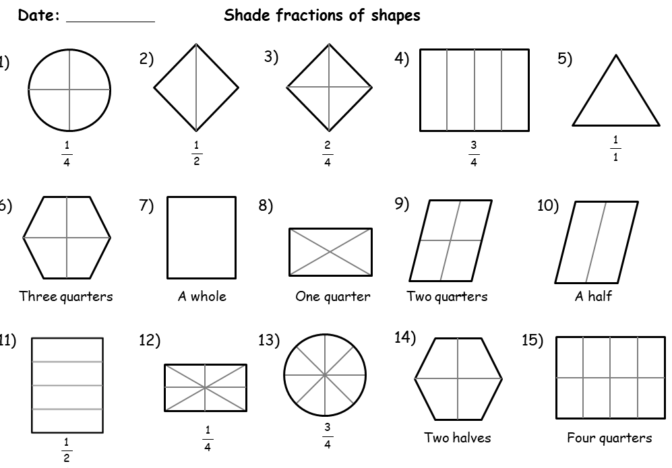

Speaking and listening Game





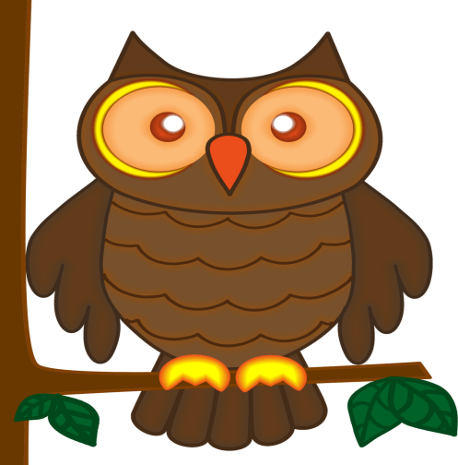





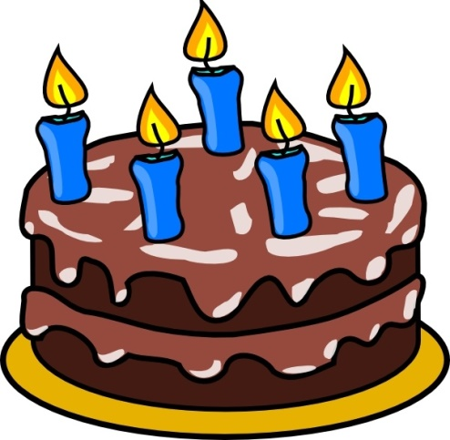
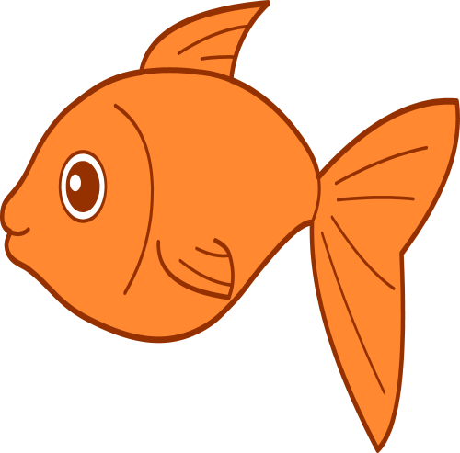

Game Rules- Game suitable for 2 players or more. Cut out pictures.
Player 1 takes a picture and hides it from all other players. The remaining players ask questions to try and guess what the object player 1 is hiding. Or
All players take a picture and place on fore head without looking. Ask questions to work out what picture is on your own head.

Seen and Saw
One if the most common errors in grammar is the misuse of the words seen and saw.
If the word ‘have’ is used then the word seen is correct.
Complete the following sentences.
- That is the fluffiest kitten I have ever __________.
- Last night I ___________ two witches flying on their brooms.
- Have you __________ my slippers?
- I ___________ Dave at the cinema the other day.
- No one has ___________ the scissors for days.
- I ____________ a shooting star.
- I have _____________ a solar eclipse.
- I wish I could have ____________ Santa when he was in my house.
- I have never _______________ the tooth fairy.

Write some sentences of your own using seen and saw correctly.
__________________________________________________________________________________________________________________________________________________________________________________________________________________________________________________________

