Year 2
Friday 8th May Activities
Purple Mash Activities
Activity 1-Spelling  - Home  - English  - Spelling resources  - Year 2  - Y2 Aut 1 wk2 Quiz | Activity 2- Grammar  - Home  - English  - Grammar  - Hatching out  - Fruit tree word spot  Remember  singular means 1 and  plural means more than 1. | Activity 3-Writing  - Home  - English  - Profile Writing  - Profile of a superhero  Remember  You could write about a real life superhero you know such as a nurse or key worker. It could even be about Captain Tom!
Activity 4 –Maths  - Home  - Maths  - 2 graph  - Fill the columns with the correct information.  Item number  Ladybird 5  Granny Grey 23  Spider 9  Robin 1  Sparrow 6  Beetle 8  Bumble bee 7  Remember  Click on chart title and think of a suitable title for your graph.  Click on the graph icons and investigate the different types of graphs. | Activity 5-Art  - Home  - Art  - Flags  - Flag  Can you design your own flag to hang in the window or on your house as bunting? | Activity 6 – Computing  Home  Computing  2DIY3D  Can you create your own maze game?

Paper based Activities
Maths- Can you roll a dice to create 2; 2 or 3 digit a numbers? Add the numbers together using the column method. If you haven’t got a dice at home google interactive dice for kids.
E.G. Roll 4 and a 3 = 43 and roll 6 and a 1 = 61
61
+ 43
______
Red group- roll 2 3-digit numbers
Blue and Green roll 2 2-digit numbers

Role play- Can you use the items at home to set up a shop? Don’t forget to label the prices. Ask your family members to come visit and by things from your shop. Don’t forget to add the prices correctly and give change.
Children in Red group- prices up to £10.00
Blue group- prices up to £2
Green group- multiples of 10’s up to £1.
Eg – 20p and 30p = 50P

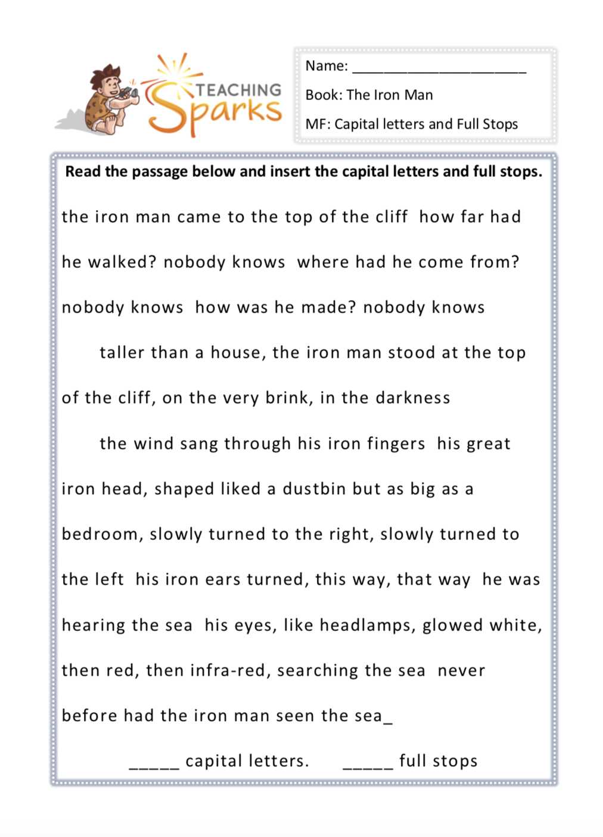
Literacy- Red Group

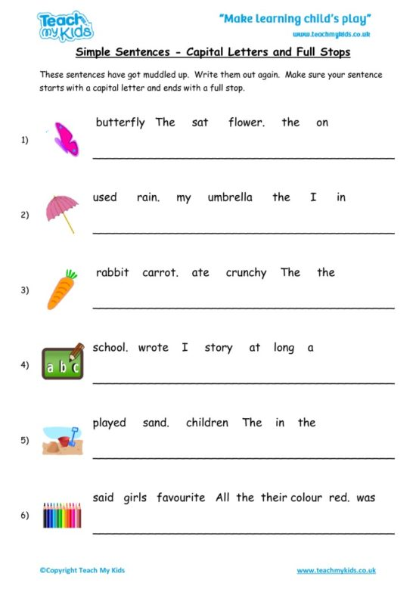
Literacy- Blue and Green Group

Stem- Can you design and build a Lego maze. Can you give it to a family member to complete? To make it harder leave gaps so you marble can roll out of the maze. Time how long it takes each member of your family to complete.
Remember no cheating!
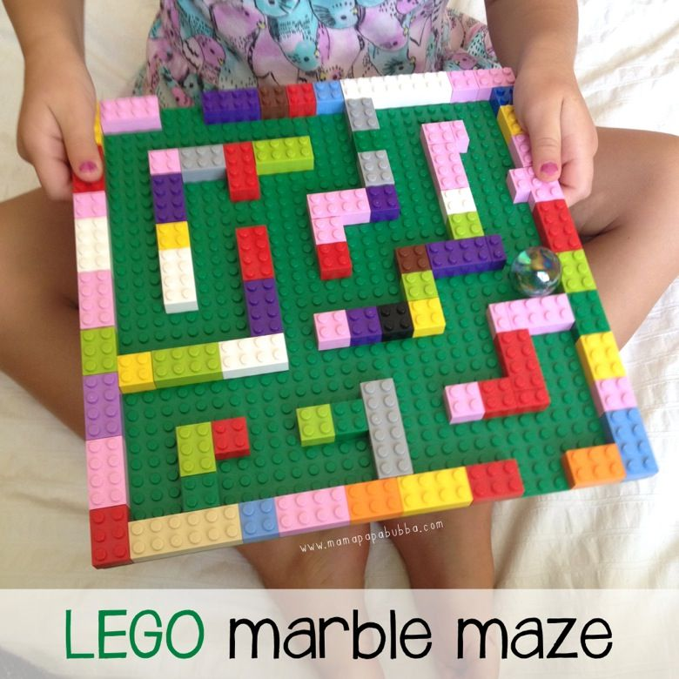
If you haven’t got a marble roll up a piece of paper or tinfoil.

Name | Time taken

Creative – can you use clean recycling materials to create a junk model house? You can paint or decorate it and even include you rainbow pictures in the windows or flag bunting if you have any. Here are a few ideas to get you started.
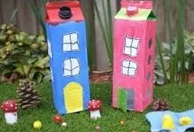
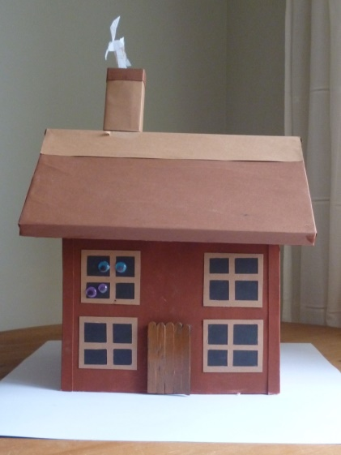

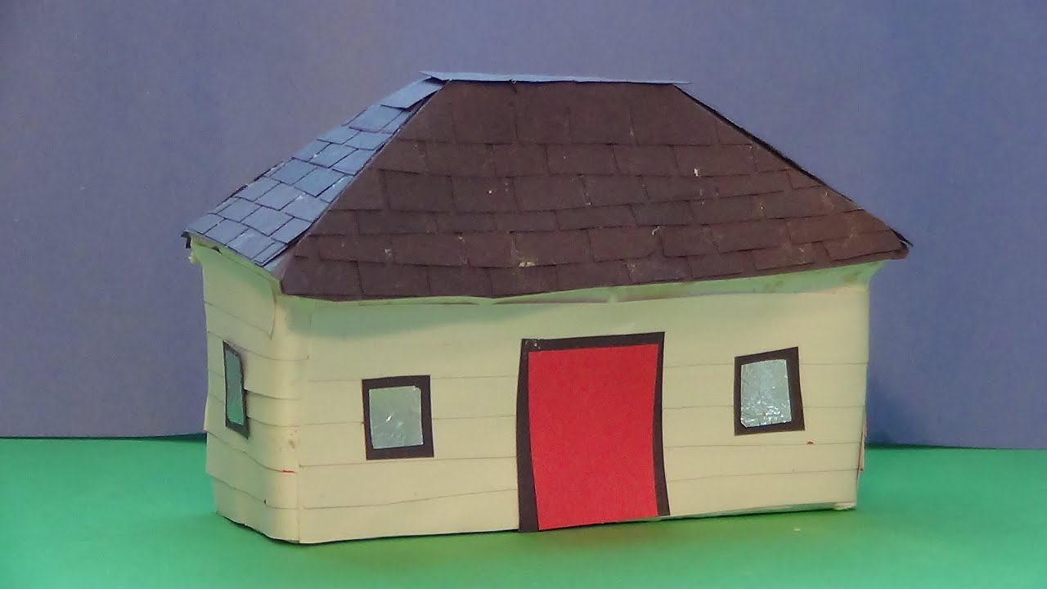

Please don’t forget to continue to use doodle maths, doodle spell and doodle tables; aswell as teacher your monster to read and websites suggested in the school packs.
I LOVE seeing all your work don’t forget to upload and tag Maerdy Primary on facebook!
take care and stay safe
love Mrs Lloyd

