Year 2 Activities
Object | Tally | Total
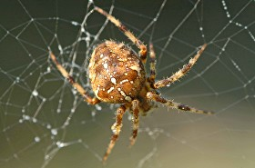

Garden Spider
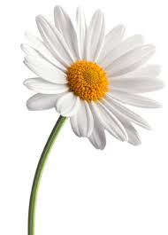

Daisy
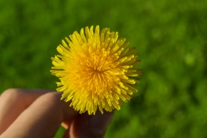

Dandelion
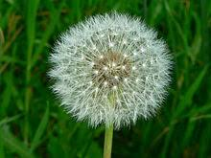

Fairy clock
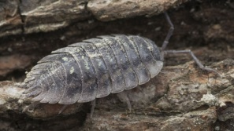

Granny Grey (woodlouse)
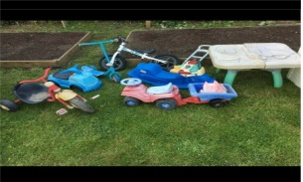

Garden toy
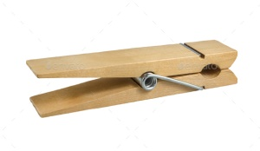

Clothes peg
Can you search in your garden and complete the tally chart? Remember to use

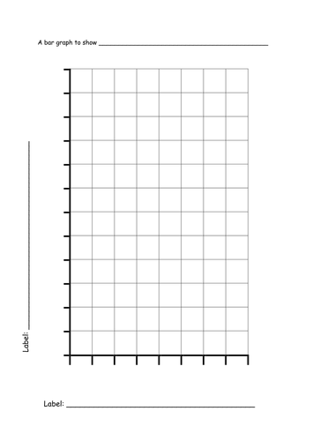
A graph to show My Garden Tally chart
Can you use the information you collected to complete the bar graph?
A bar graph to show the objects found in my garden

120
110

100

90
80

70
Number of objects found (counting in 1’s)
60
50

40
30

20

10
00
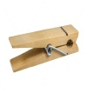
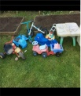
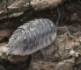
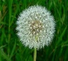
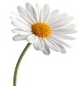
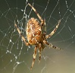

Object found in my garden
Can you use the information you collected to design and complete a bar graph?
Remember to label the both axis.
(You can count in 1’s,2’s,5’s or 10’s. Think which number is most appropriate)

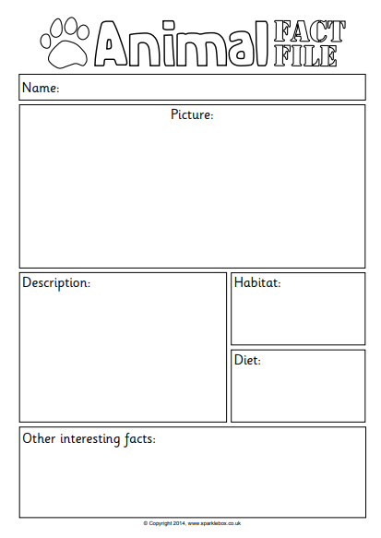
Can you create a factsheet about an animal or insect that lives in your garden? Make it bright, colourful and interesting.

Can you use junk material to make a bug hotel or bird feeder?
You can place it in your garden and observe which animals use it.
Here are some ideas to get you started. Good luck and enjoy.


