Lo- to create an information text
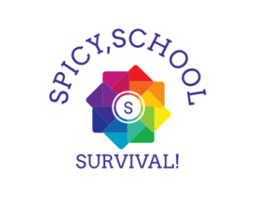
Spicy, School, Survival
Introduction

‘Spicy, School, Survival’ is a relatively new reality show that already has millions of fans. It was aired October 17th and swiped the world off their feet. People must stay in an ordinary classroom for as long as they can, with challenges and lots more. At the end you will find out who is the last person standing. The prize is a tranquil, pastoral and calm trip to Miami, Florida and monumental amount of money (£30,000). The captivating thing about this Prodigious, Fascinating and Astonishing series is that is that instead of waiting a whole week for another episode to come out, a new episode comes out every day. The challenges are very difficult that contestants were authorized to everyday.
Spicy, School,Survival! Logo
There are camera’s everywhere!
Structure
The show will be live on ITV 2 at 4:30 – 5:30 everyday (UK time). To get someone eliminated you must vote on the ‘Spicy, School, Survival’ app and choose who you want to stay and who you wish to get eliminated, when the votes are in, they will gather around the pencil pit and collect in the votes. The show happens every 2 months with different people on it every series.

Cast
Series 1
Gracie Eve Harrison- Good leader, Good talker
Laynie Grace Jones- Sporty and Likes Company
Nia Margret Coleman- Sense of humor and musical
Brandy Star Holmes- Creative and Good listener
Picture of a school
The future
In the last month the show has become acclaimed because of its flaws. It has proved a lot in the past few weeks. Here are some clips of the show...

